Project Report
Title: National Child Incident Database (Minnesota – Pilot)
Organization: Kids At Risk Action (KARA)
Team: FNU Sanober, Uday Kumar Eepu, Frank Hablawi
Submission Date: 20th August 2025

Executive Summary
This capstone project was completed in partnership with Kids At Risk Action (KARA), a nonprofit organization that has been working since 2001 to improve the lives of abused and neglected children. Founded by Mike Tikkanen, KARA has long argued that one of the biggest barriers to protecting children is the lack of reliable and accessible data. Information about child maltreatment, poverty, foster care, arrests, and child deaths exists, but it is often fragmented across different agencies, difficult to interpret, and not presented in a way that can support timely decisions. As a result, policymakers lack clarity, advocacy groups lack evidence, and many children remain invisible within the system.
Our project set out to address this challenge by creating a unified reporting system. The original goal was to design a national child welfare database, but after discussions with our sponsor and consideration of data availability, the team and KARA decided to begin with a Minnesota-specific pilot. Minnesota was chosen because it has relatively strong, consistent data compared to other states. By focusing on one state, we were able to build a high-quality model that provides immediate value to KARA and creates a framework that can later be expanded nationally.
The solution combined three main components: data collection and preparation, database creation, and visualization. We gathered more than forty datasets from sources such as the Minnesota Department of Human Services, Safe Passage for Children, Minnesota Compass, and other public data centers. These covered a wide range of topics including child protection reports, socioeconomic factors like poverty and teen births, juvenile justice, and child mortality. Using Python (Pandas) and Excel Power Query, we cleaned and standardized the data so it could be merged consistently across counties and years. We then built an SQL database to store the data in a structured, relational format, ensuring scalability and efficiency. Finally, we developed a set of interactive Tableau dashboards that transform this database into clear, user-friendly visuals.
The dashboards focus on five key areas: socioeconomic context, child protection system reports, victim characteristics, severe outcomes, and juvenile justice. They allow users to see not only what is happening in Minnesota overall, but also how risks and outcomes vary by county, demographic group, and year. The result is a platform that takes information once buried in spreadsheets and reports and makes it easy to explore, easy to understand, and ready for advocacy.
The impact of this work has been significant. For the first time, KARA has a single system that brings together multiple streams of child welfare data into one accessible platform. The dashboards provide evidence-based insights into systemic risks and disparities, while also supporting community awareness and policy discussions. Instead of relying on scattered and complicated reports, KARA can now tell the story of child welfare in Minnesota with clarity and credibility.

- Organization and problem context

Kids At Risk Action (KARA) is a nonprofit dedicated to improving the lives of abused and neglected children. Founded in 2001 by Mike Tikkanen, a longtime court-appointed special advocate (CASA), KARA works to raise awareness, share research, and inform policymakers about what children need to be safe and to thrive. Mike’s experience showed him how children are often overlooked when data is scattered or hidden, and KARA’s mission is to bring these facts into the open to drive better decisions.
In Minnesota, child welfare data is spread across many agencies and reports, covering maltreatment, foster care, poverty, arrests, and child deaths, yet rarely combined into a single view. This fragmentation makes it difficult for advocates, county leaders, and lawmakers to see patterns such as where risks are growing or which groups need the most support. Communities want to act, but they need trustworthy, accessible information to do so effectively.
Our project addressed this challenge by working with KARA to build a unified reporting system for Minnesota. Minnesota was chosen because of its relatively strong and more consistent data, making it an ideal pilot. The goal was to create clear, easy-to-use dashboards that bring together county- and year-level data, allowing users to spot risks sooner, have fact-based discussions, and direct resources where they are most needed. This Minnesota model also lays the groundwork for KARA’s larger vision of a national child welfare database, promoting transparency and accountability across the country.

Business Problem Statement
The main business problem addressed in this project is the lack of a unified system for understanding child welfare in Minnesota. Information about child abuse, neglect, foster care, juvenile arrests, poverty, and child deaths is scattered across multiple agencies and reports. Each source uses different formats, covers different years, and measures variables in inconsistent ways. This fragmentation makes it extremely difficult to see the bigger picture of child welfare in the state.
Without a clear and combined view of the data, leaders struggle to identify which counties face the greatest risks, whether certain groups of children are being treated unfairly, or how economic conditions like poverty and teen births connect to child protection outcomes. As a result, decisions about policy, funding, and services are often made without strong evidence. This leads to resources being spread thin or directed to the wrong areas, while some children remain unseen and unsupported.
For Kids At Risk Action (KARA), this lack of visibility is a major limitation. KARA’s mission is to raise awareness and push for better policies to protect vulnerable children, but without reliable and accessible data, it is difficult to communicate the full story to lawmakers, communities, or the public. The absence of a unified system leaves advocates without the tools they need to make informed, evidence-based arguments for change.

- Analytical Problem Statement
The analytical challenge in this project came from the nature of child welfare data itself. Information is spread across dozens of sources, including Excel sheets, government dashboards, PDFs, and public reports. Each source organizes and reports data differently. Some use years as columns, while others stack years in rows. Some provide detailed county-level data, while others only share statewide totals. On top of this, many datasets have missing values, incomplete records, or inconsistent labels for the same variables.
Because of these differences, the data cannot be compared or connected in its original form. Without consistency, it is impossible to answer basic but important questions such as: How do socioeconomic factors relate to child protection reports? Are certain counties or groups of children facing greater risks? What trends in child deaths or juvenile arrests require urgent attention?
The core analytical problem, therefore, was not simply gathering data but finding a way to make it reliable, consistent, and comparable. Unless the data could be aligned across counties and years, decision-makers, advocates, and communities would continue to face confusion and blind spots instead of clear, actionable insights.

- Problem-Solving Approach
To address the challenges identified, our team followed a structured process that combined data engineering, database design, and visualization. The goal was to create a product that was technically reliable while remaining accessible to non-technical audiences.
The first step was data collection and cleaning. We compiled more than sixty datasets from government agencies, nonprofits, and public portals. These included data on child protection reports, poverty, income, teen births, juvenile arrests, and child mortality. Because the datasets varied in format and often contained missing values or inconsistent labels, we standardized them using Python (Pandas) and Excel Power Query. County and year identifiers were added to ensure consistency across all sources.
The second step was database creation. To move beyond dozens of individual files, we designed a SQL database with relational tables linked by county and year. This structure supported efficient queries, scalable storage, and the ability to generate stored views and summary tables for analysis and visualization.
The third step was visualization and dashboard development. We connected the SQL database to Tableau and created five interactive dashboards. These covered socioeconomic factors, child protection reports, victim profiles, severe outcomes, and juvenile justice. Each dashboard was designed to be clear, user-friendly, and visually compelling, using maps, charts, and filters to enable exploration without technical training.
The final step was presentation and storytelling. Collaborating closely with our sponsor, Mike Tikkanen, we refined the dashboards to align with KARA’s advocacy goals. A presentation deck was also developed to highlight the problem, present the data, and communicate the urgent need for action.
By combining robust data cleaning, a centralized SQL database, and interactive dashboards, this project transformed fragmented information into a reliable and actionable tool for child welfare advocacy.
- Findings and Results; how does it solve the business problem?
The project delivered a unified reporting system that consolidates Minnesota child welfare data into a SQL database with interactive Tableau dashboards. This solved the problem of fragmented and inaccessible information, making insights easier to use and share.
The dashboards revealed key patterns: socioeconomic factors like poverty and teen births correlate with higher caseloads; American Indian children are disproportionately screened into investigations; neglect is the most common form of maltreatment; and many child deaths and suicides occur without prior child protection involvement. Juvenile arrest data also highlighted overlaps between the child welfare and justice systems.
More importantly, the system makes these insights visible and actionable. Instead of scattered spreadsheets, stakeholders now have clear, evidence-based tools to identify risks, support advocacy, and guide decisions. For KARA, this means stronger credibility and the ability to demonstrate child welfare challenges with facts. The structure also provides a scalable foundation for expanding to other states, moving toward KARA’s vision of a national database.

- Possible Extensions of work done.
Although this project focused on a Minnesota-specific reporting system, there are many opportunities to expand it. One direction is predictive analytics, which could estimate which children or counties are most at risk of recurrence, out-of-home placements, or severe outcomes, providing early warning for policymakers and agencies. Another is real-time integration, where data pipelines connect directly to state and county systems so updates flow automatically into the database.
The framework could also be scaled nationally since the SQL structure and dashboards are flexible enough to adapt to other states. In the future, policy simulation dashboards could allow users to test scenarios, such as the effects of reducing poverty or increasing access to mental health services. Finally, simplified public-facing dashboards could raise awareness among parents, teachers, and communities.
Together, these extensions would transform the project from a reporting tool into a predictive, real-time, and participatory system, strengthening advocacy and moving closer to the vision of a national child welfare database.

Conclusion
This project shows how data can be used not just for analysis, but for real social impact. By working with Kids At Risk Action (KARA), we turned scattered and difficult-to-use information into a clear, unified system that shines a light on what is happening to children in Minnesota. Through careful data collection, cleaning, and structuring in SQL, and by building interactive dashboards in Tableau, we created a tool that is both reliable and easy to use.
The system directly addresses KARA’s challenge of fragmented data. Instead of piecing together reports from multiple sources, KARA can now show policymakers, community members, and partners a single set of dashboards that tell the story in a powerful and visual way. This makes advocacy more persuasive, resource allocation more informed, and policy discussions more grounded in evidence.
Our sponsor, Mike Tikkanen, has expressed strong satisfaction with the results and sees this as the beginning of something larger. He has encouraged us to continue building toward the vision of a national child welfare database and even invited us to share our work with one of his professional contacts to demonstrate its potential. This shows the credibility of the project and the trust it has built.
In the bigger picture, this project highlights the value of combining analytics and storytelling. Data alone can be overwhelming, and stories alone can feel incomplete. By bringing them together, we created something that is practical, impactful, and scalable. This Minnesota-focused system is a strong first step toward greater transparency in child welfare, and it lays the foundation for a future where children across the country are better seen, understood, and protected.

Appendix

A. Project Charter
Attached is the original Project Charter prepared for the KARA National Child Incident Database project. The charter outlines the goals, scope, deliverables, and responsibilities of the team. (National Child Incident Database - Project Charter)

B. Summary of Sponsor Meeting
This section includes the summary of the initial Zoom meeting held with sponsor Mike Tikkanen. The discussion focused on defining the project vision, selecting Minnesota as a pilot state due to better available data, and planning the first deliverables such as the database and dashboards. Key accomplishments include agreeing on goals, scope, and next steps. See attached meeting summary document for full details. (Summary of meeting with Mike)
C. Annotated Bibliography
This section includes an annotated bibliography of key references consulted during the project. Each source was reviewed for relevance to nonprofit dashboard development, data reporting practices, and visualization strategies for advocacy. The annotations summarize the contribution of each reference and how it related to the project’s design, execution, or future extensions. See attached annotated bibliography document for full details. (Appendix C: Annotated Bibliography)

D. Dataset Sources
The datasets used for this project were gathered from multiple sources including government agencies, nonprofits, and public portals. The attached file contains the complete list of links to these datasets for transparency and reproducibility. (Links to Sources)

E. Data Cleaning Notes
The data cleaning process involved multiple steps conducted in Python (Pandas), Excel Power Query, and manual adjustments. Key activities included:
- Standardizing column names across datasets.
- Converting wide tables into long format for consistency.
- Adding missing County and Year identifiers.
- Handling missing values by replacing blanks with NaN.
- Ensuring consistent categorical labels (e.g., race, gender, maltreatment type).
- Merging datasets based on County and Year.
Cleaning was iterative and files were prepared until they were dashboard-ready, as reflected in the final Excel file.

Appendix E: Cleaning Visuals
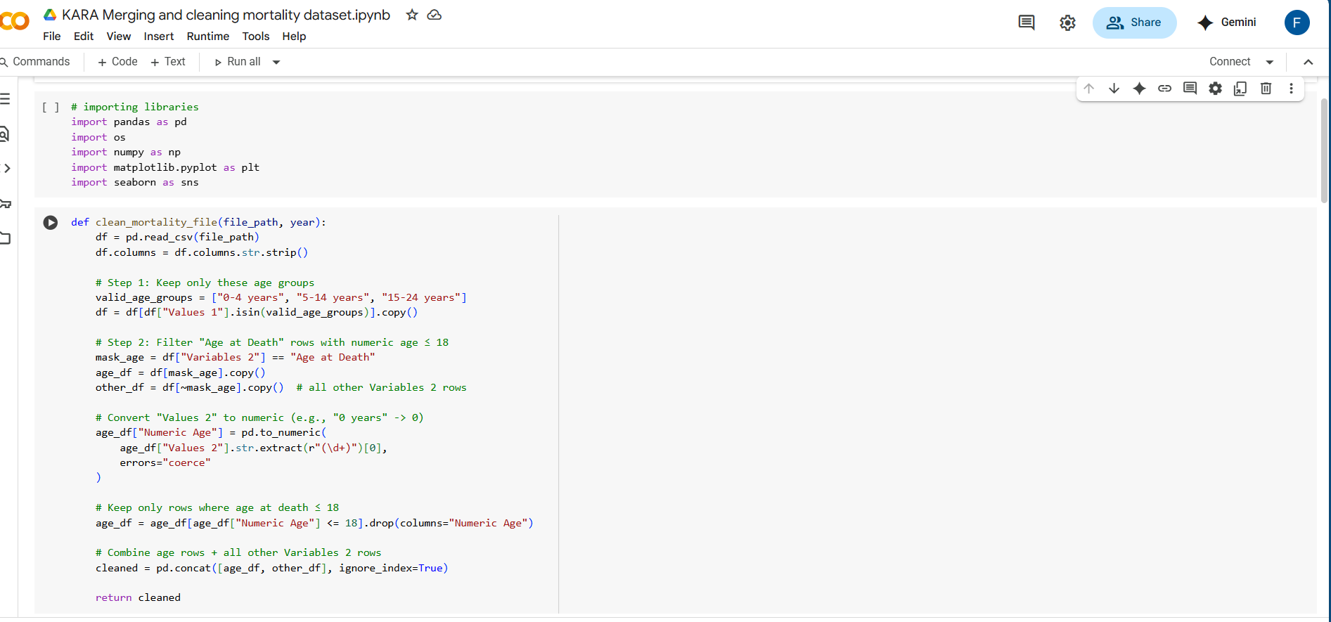

F. SQL Database & ER Diagram
The SQL database design included relational tables linked by County and Year. The Entity-Relationship (ER) diagram designed for this system shows the relationships between datasets such as Socioeconomic Factors, Child Protection Reports, Victim Profiles, Severe Outcomes, and Juvenile Justice.
Tables included:
- Counties (CountyID, CountyName)
- Years (YearID, Year)
- SocioeconomicData (CountyID, YearID, PovertyRate, MedianIncome, TeenBirths)
- ChildProtectionReports (CountyID, YearID, ScreenedIn, ScreenedOut, Reasons)
- VictimProfiles (CountyID, YearID, AgeGroup, Gender, Disability, MaltreatmentType)
- SevereOutcomes (CountyID, YearID, Deaths, Suicides, Homicides)
- JuvenileJustice (CountyID, YearID, Arrests)

Appendix F: SQL Database & ER Diagram
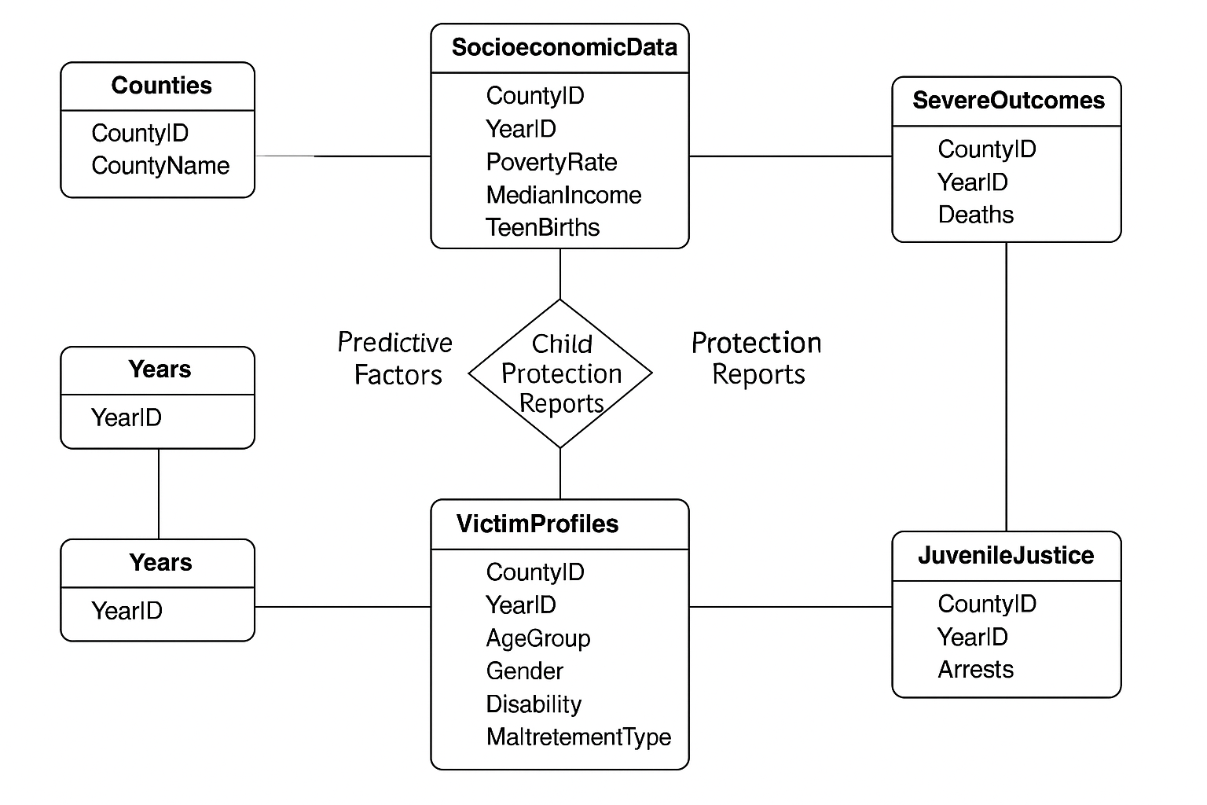

G. Dashboard Visuals
The following visuals represent the Tableau dashboards created from the cleaned datasets. Dashboards include Socioeconomic Reporting, Child Mortality, Victim Profiles, Juvenile Justice, and Youth Suicides. Screenshots are attached as image files to illustrate the final outputs.

Appendix G: Dashboard Visuals

Socioeconomic Reporting Dashboard
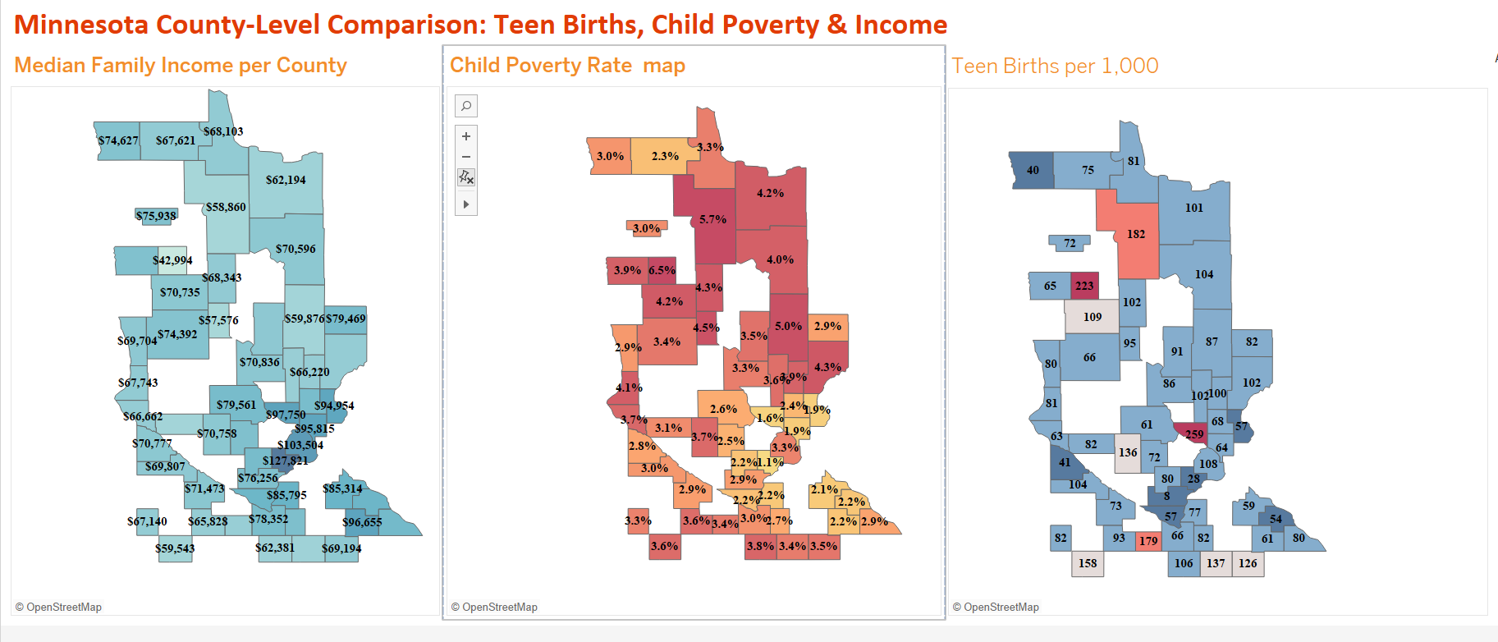

Victim Profiles and Characteristics Dashboard
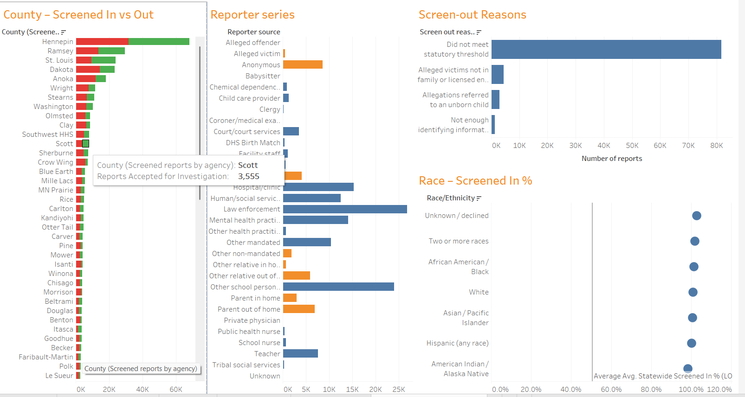

Child Mortality Dashboard
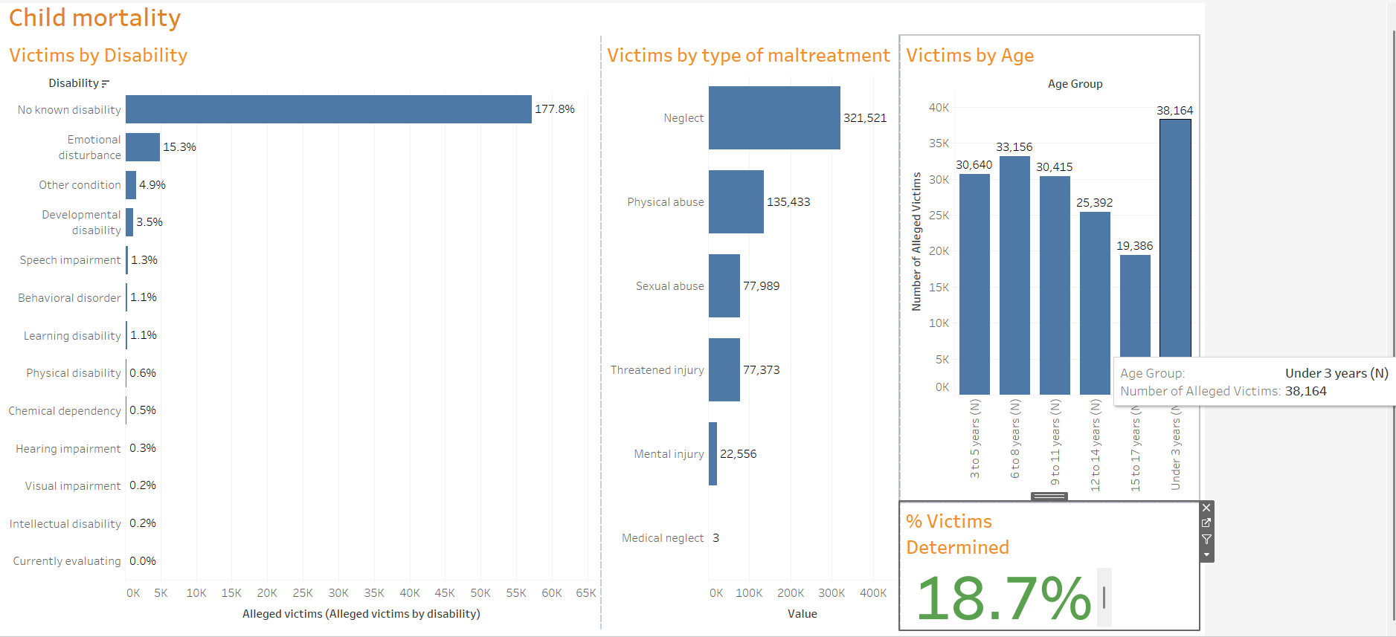

Juvenile Justice Dashboard
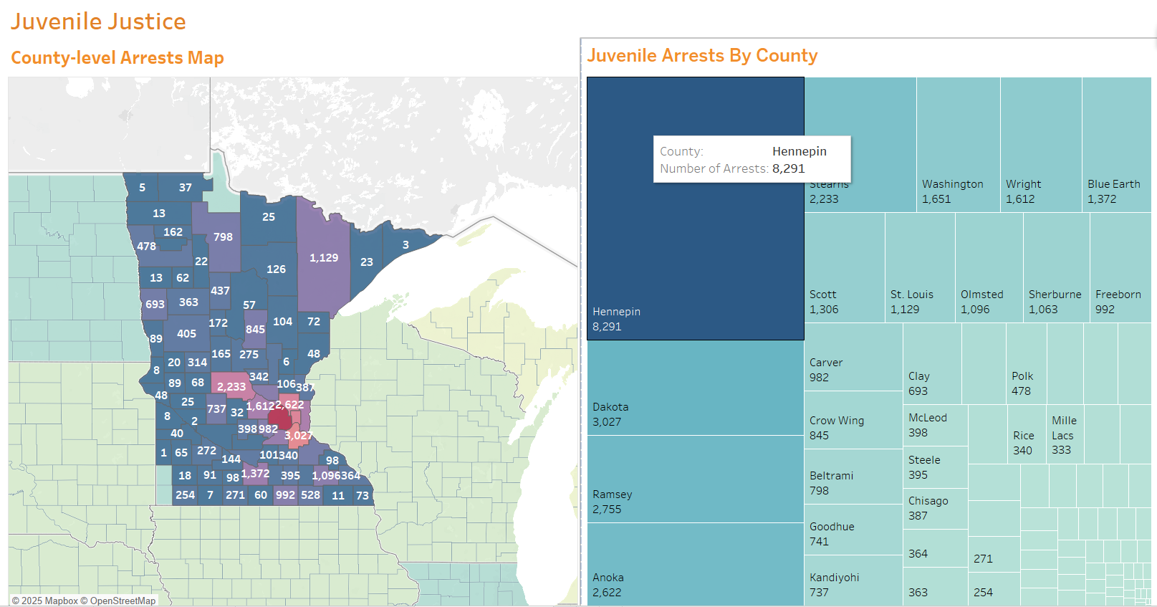

Youth Suicides Dashboard
